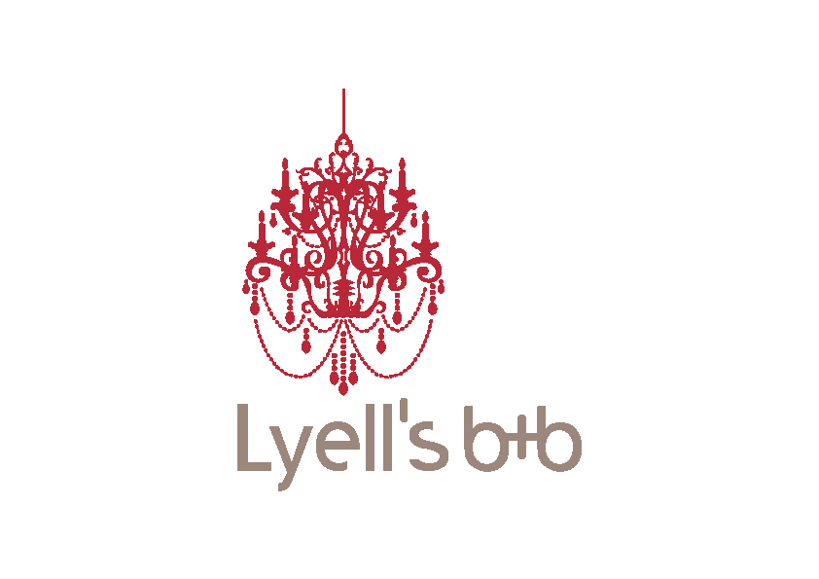

JANUARY – APRIL 2016
Bed & Breakfast | R500 pppd Sharing | R700 pppd Single
Self-catering | R450 pppd Sharing | R650 pppd Single
MAY – AUGUST 2015
Bed & Breakfast | R350 pppd Sharing | R500 pppd Single
Self-catering | R300 pppd Sharing | R450 pppd Single
SEPTEMBER - NOVEMBER 2015
Bed & Breakfast | R500 pppd Sharing | R700 pppd Single
Self-catering | R450 pppd Sharing | R650 pppd Single
DECEMBER 2015
Bed & Breakfast | R650 pppd Sharing | R1100 pppd Single
Self-catering | R600 pppd Sharing | R950 pppd Single
CHILDREN’S RATES
No Charge: 0 – 5 years
½ Price: 6 – 11 years (if sharing with full)
Full Rate: 12 years and up

Lyell`s B&B – Cancellation Terms

- Cancellation 0 - 14 days before date of arrival, or Guest does not arrive: Guest forfeits 100% of deposit paid.
- Cancellation 15 -28 days before date of arrival: Guest forfeits 75% of deposit paid or 25% of full quote value (whichever is the greater)
- Cancellation 29 days before date of arrival: Guest forfeits 50% of deposit paid or 25% of full quote value (whichever is the greater)
- In the event of the Guests premature departure we may charge for the full amount of the original booking.

